Imaginary error function

Def

$$erfi\left(z\right)$$

= $$−i⋅erf\left(iz\right)$$

$$erfi\left(z\right)$$

= $$\frac{2}{pi{\left(\right)}^{\frac{1}{2}}}⋅erfi\left(\frac{z^{2n+1}}{n!\left(2n+1\right)},n=0,n=\inf{}\right)$$

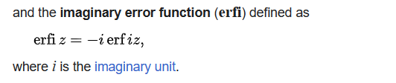

$$erfi^{−1}\left(z\right)$$

= $$z⋅erfi\left(z\right)−\frac{e^{−z^{2}}}{pi{\left(\right)}^{\frac{1}{2}}}$$

Inverse function

$$erfi^{−1}\left(z\right)$$

= $$sigma\left(\frac{{\left(−1\right)}^{k}c_{k}}{2k+1}⋅{\left(\frac{pi{\left(\right)}^{\frac{1}{2}}}{2}z\right)}^{2k+1}\right)$$

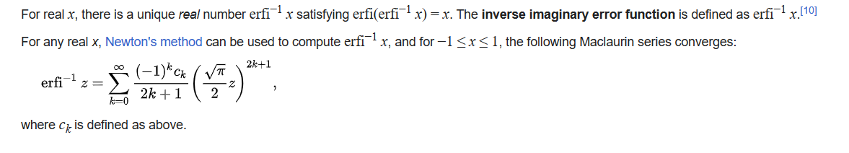

Dawson function

Erfx

$$erfi\left(z\right)$$

= $$\frac{2}{pi{\left(\right)}^{\frac{1}{2}}}⋅e^{x^{2}⋅}D\left(x\right)$$

where $$D\left(x\right)$$ denotes Dawson function.

Ref

[Error function - Wikipedia](https://en.wikipedia.org/wiki/Error_function)